Which of the following options correctly represent the full form of acronyms NLTK and VADER

 NLTK: Normal Language Toolkit, VADER: Valence Aware Dictionary and Emotional Reasoner

 NLTK: Natural Language Toolkit, VADER: Valence Aware Dictionary and Sentiment Reasoner

 NLTK: Normal Language Toolkit, VADER: Valence Aware Dictionary and Sentiment Reasoner

 Natural Language Toolkit, VADER: Valence Aware Dictionary and Emotional Reasoner

Yes, the answer is correct.  
Score: 1

Accepted Answers:

*NLTK: Natural Language Toolkit, VADER: Valence Aware Dictionary and Sentiment Reasoner*

***1 point***

Predict the output  
  
 

 [’ ’, ’!’, ’A’, ’H’, ’I’, ’a’, ’b’, ’h’, ’i’, ’m’, ’t’]

 [’!’, ’A’, ’H’, ’I’, ’a’, ’b’, ’h’, ’i’, ’m’, ’t’]

 !AHIabhimt

 !AabHhIimt

Yes, the answer is correct.  
Score: 1

Accepted Answers:

*[’ ’, ’!’, ’A’, ’H’, ’I’, ’a’, ’b’, ’h’, ’i’, ’m’, ’t’]*

***1 point***

Which of the scenarios in the options does the following code represent?  
  
 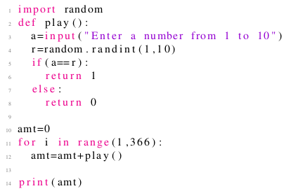

 A person going to the bar for an year. Daily he guesses a number from 1 to 10. If the guessed number if equal to the number randomly generated by bar authority, he gains one gold coin.

 A person going to the bar for a month. Daily he guesses a number from 1 to 10. If the guessed number if equal to the number randomly generated by bar authority, he gains one gold coin.

 A person going to the bar for an year. Daily he guesses a number from 1 to 10. If the guessed number if equal to the number randomly generated by bar authority, he loses one gold coin.

 A person going to the bar for a month. Daily he guesses a number from 1 to 10. If the guessed number if equal to the number randomly generated by bar authority, he loses one gold coin.

Yes, the answer is correct.  
Score: 1

Accepted Answers:

*A person going to the bar for an year. Daily he guesses a number from 1 to 10. If the guessed number if equal to the number randomly generated by bar authority, he gains one gold coin.*

***1 point***

Which of the scenarios in the options does the following code represent?  
  
 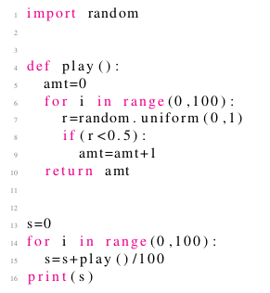

 Simulates a game play 100 times. In each play, a coin is tossed 100 times and player is given money equal to the number of heads he get. The code displays the average money earned by the player amongst all 100 plays.

 Simulates a game play 100 times. In each play, a coin is tossed 100 times and player is given money equal to the number of heads he get. The code displays the total money earned by the player amongst all 100 plays.

 Simulates a game play 100 times. In each play, a coin is tossed 100 times and player is given money equal to the number of heads he get. The code displays the money earned by the player in first play.

 none of the above

Yes, the answer is correct.  
Score: 1

Accepted Answers:

*Simulates a game play 100 times. In each play, a coin is tossed 100 times and player is given money equal to the number of heads he get. The code displays the average money earned by the player amongst all 100 plays.*

***1 point***

Which of the plots in the options is most likely to be generated from the following code?  
  
 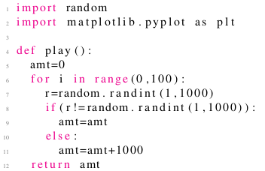  
 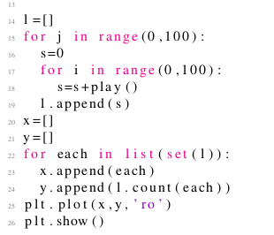

 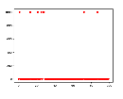

 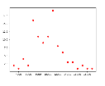

 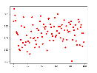

 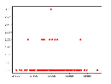

Yes, the answer is correct.  
Score: 1

Accepted Answers:

**

***1 point***

Which of the plots in the options is most likely to be generated from the following code?  
  
 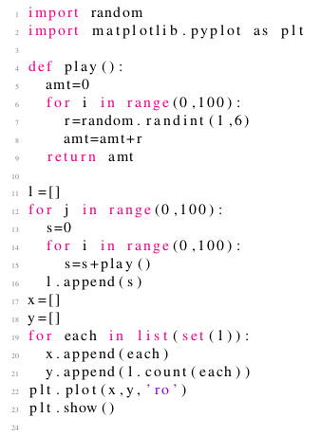

 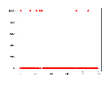

 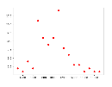

 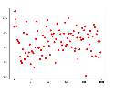

 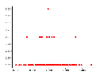

Yes, the answer is correct.  
Score: 1

Accepted Answers:

**

***1 point***

What is the output of the following code?  
  
 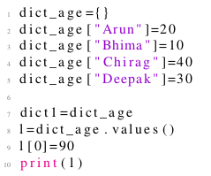

 [20,10,40,30]

 [90,10,40,30]

 [10,20,30,40]

 Error

Yes, the answer is correct.  
Score: 1

Accepted Answers:

*Error*

***2 points***

Which of the scenarios in the options does the following code represent?  
  
 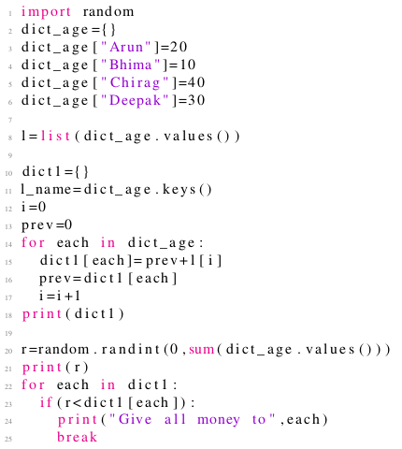

 All money is given to the oldest person

 All money is given to the youngest person

 Money is given to a person with a probability proportional to his/her age

 Money is given to a person with a probability inversely proportional to his/er age

Yes, the answer is correct.  
Score: 2

Accepted Answers:

*Money is given to a person with a probability proportional to his/her age*

***1 point***

Which of the scenarios in the options does the following code represent?  
  
 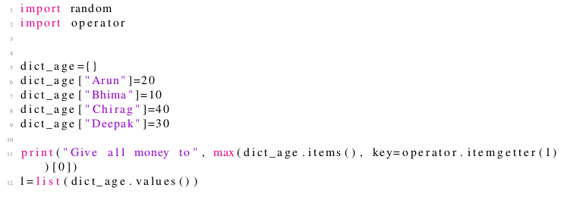

 All money is given to the oldest person

 All money is given to the youngest person

 Money is given to a person with a probability proportional to his/her age

 Money is given to a person with a probability inversely proportional to his/er age

Yes, the answer is correct.  
Score: 1

Accepted Answers:

*All money is given to the oldest person*